CS 255 Project Two
DriverPass System Design
Design overview: This document completes the DriverPass system design with UML diagrams and technical requirements. The design supports online training, practice testing, appointment scheduling, staff management, reporting, payment processing, and updates to DMV-based content.

UML Use Case Diagram
The use case diagram shows the major ways customers, employees, administrators, and outside services interact with the DriverPass system. It includes customer account access, training packages, online course tools, practice exams, lesson scheduling, staff appointment management, instructor lesson notes, administrator reports, payment processing, and DMV update support.
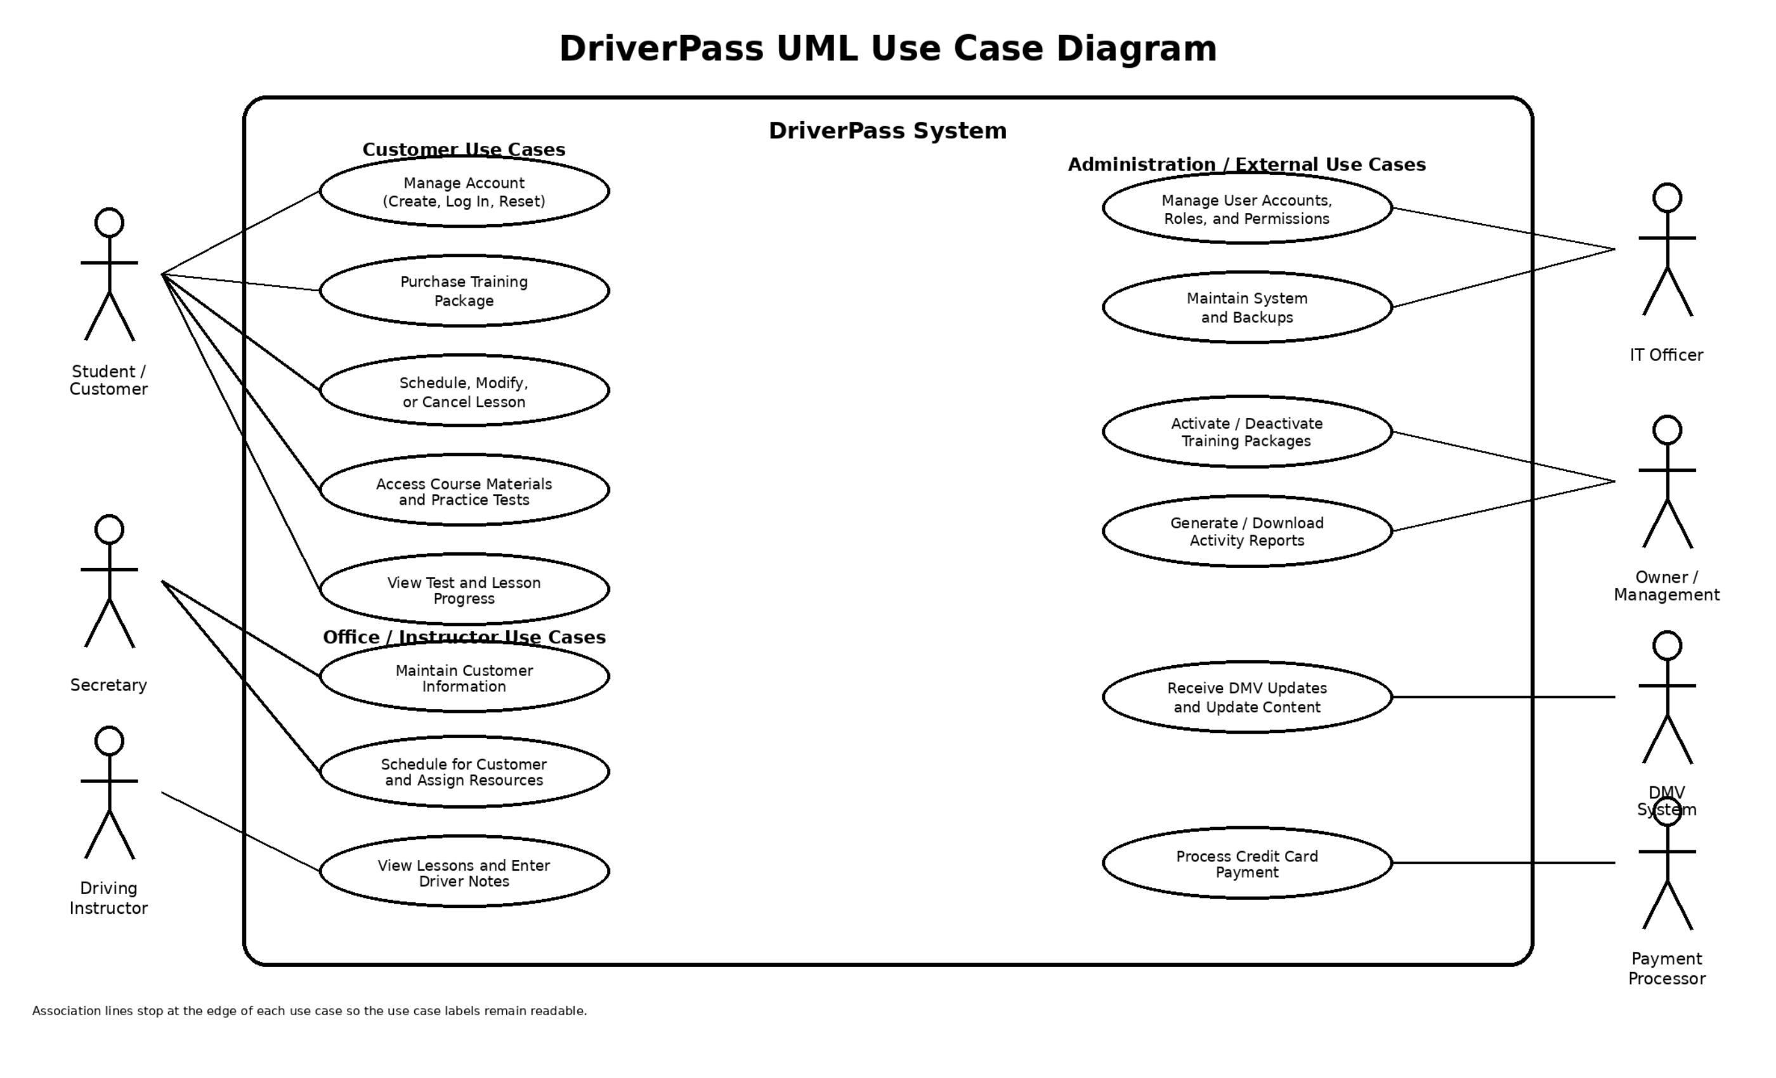
Figure 1. DriverPass UML use case diagram

UML Activity Diagrams
The first activity diagram breaks down how a customer schedules a driving lesson. The design checks that the customer has an active package, confirms instructor availability, handles payment when needed, and sends appointment notifications.
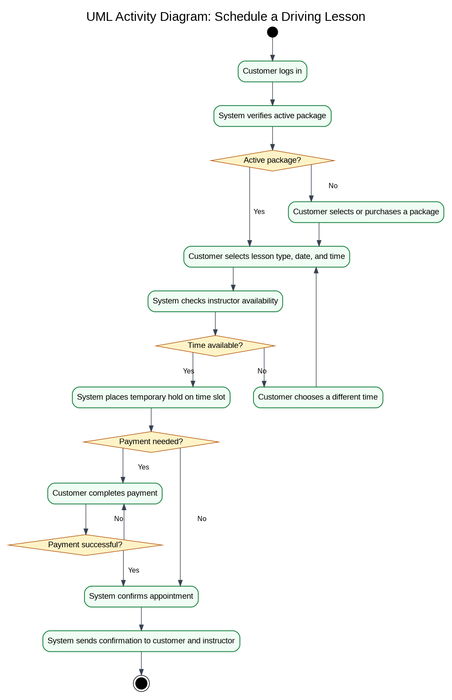
Figure 2. Activity diagram for scheduling a driving lesson
The second activity diagram breaks down how a customer takes a practice exam. The design uses current DMV-based questions, scores the exam, saves the result to the customer progress record, and allows the customer to review missed questions or retake the exam.
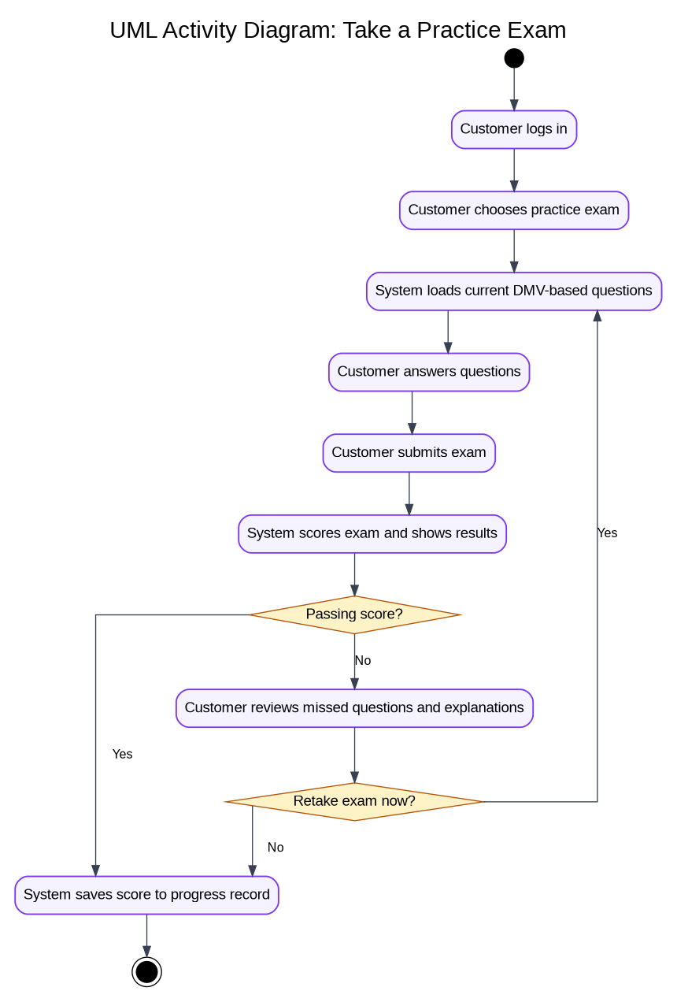
Figure 3. Activity diagram for taking a practice exam

UML Sequence Diagram
The sequence diagram demonstrates how scheduling requests move through the DriverPass system and helps ensure lessons are booked accurately, payments are verified, and customers receive confirmation without manual intervention.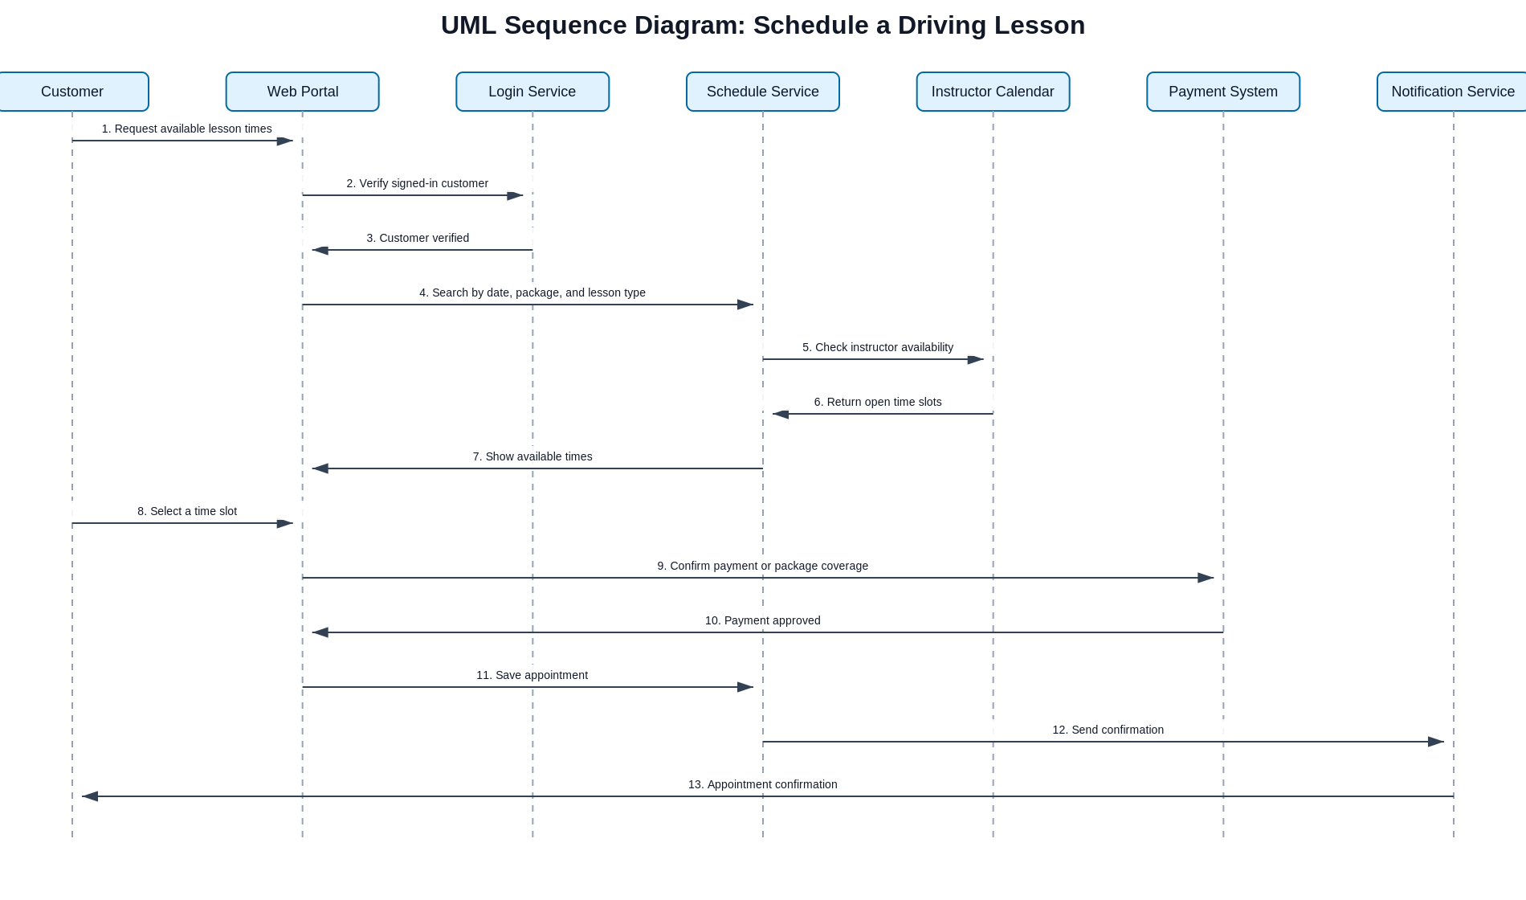
Figure 4. Sequence diagram for scheduling a driving lesson

UML Class Diagram
The class diagram identifies the main data objects the system needs. The design includes users, customers, staff roles, packages, appointments, lessons, online courses, practice exams, payments, DMV updates, and reports.
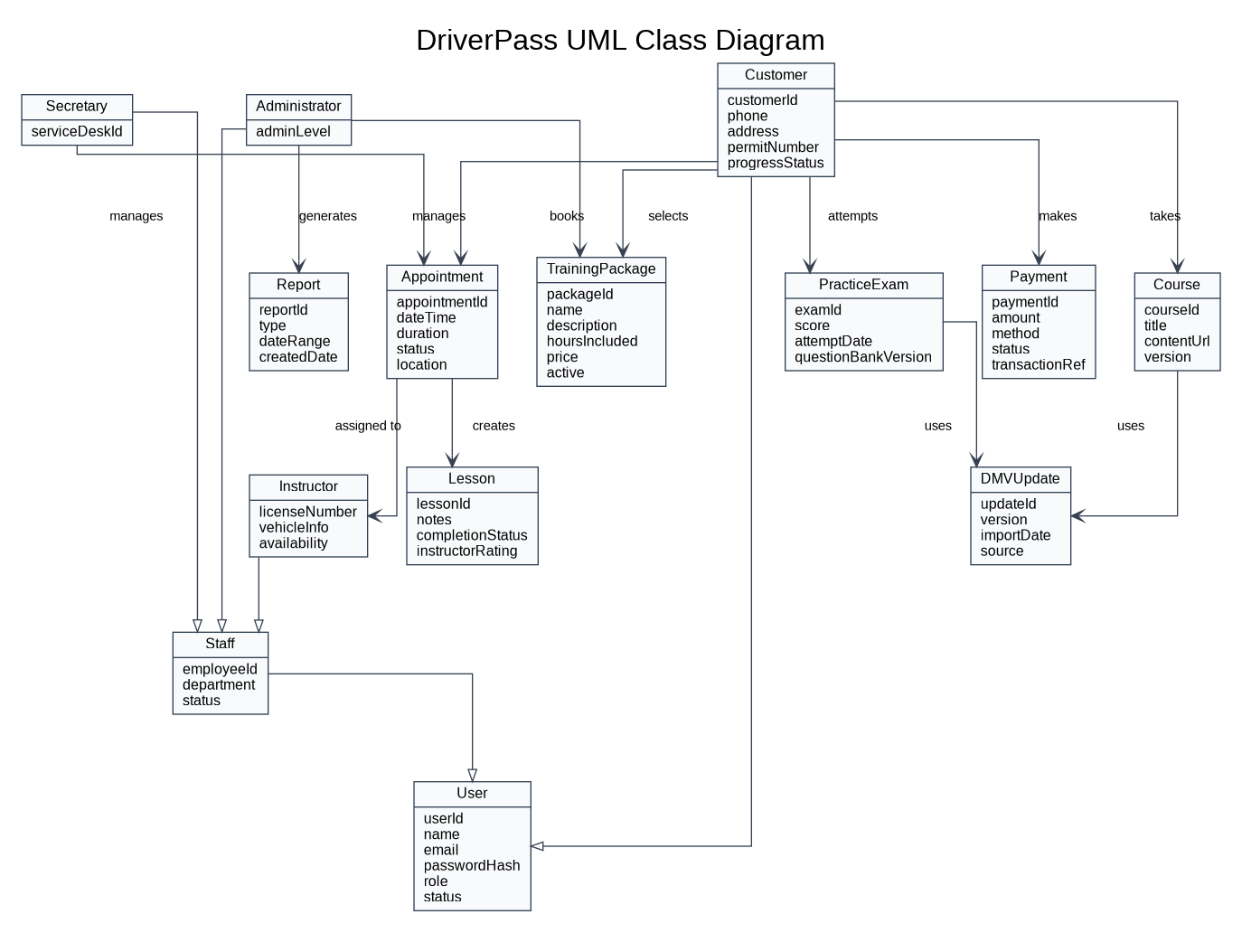
Figure 5. DriverPass UML class diagram

Technical Requirements
The following technical requirements describe the hardware, software, tools, and infrastructure needed to support the DriverPass design. These requirements are based on the functional and nonfunctional needs of the system.

Hardware and Devices
- Customer access through desktop computers, laptops, tablets, and smartphones using a modern web browser.
- Employee access through office workstations or approved laptops for secretaries, instructors, administrators, and IT staff.
- Reliable server resources through a cloud hosting provider or managed hosting environment to run the application and database.
- Secure storage capacity for customer records, progress history, appointment records, reports, and system logs.

Software
- A responsive web application for customer self-service, employee scheduling, instructor updates, and administrative reporting.
- A secure back-end application layer to process logins, scheduling rules, payments, DMV content updates, reports, and notifications.
- A relational database management system to store structured records such as users, packages, appointments, lessons, exams, payments, and reports.
- Authentication and access control software so each user role only sees the information needed for that role.
- Email or text notification service for appointment confirmations, schedule changes, password resets, and reminders.
- Payment gateway integration for package purchases and appointment-related fees.

Development and Design Tools
- Lucidchart or another CASE/UML tool for maintaining design diagrams.
- An integrated development environment for coding, debugging, and testing the application.
- Version control such as Git to manage source code, document changes, and team collaboration.
- Testing tools for validating login, scheduling, payment, reporting, and security functions before release.
- Monitoring and logging tools to identify system errors, failed login attempts, payment issues, or scheduling problems.

Infrastructure and Security
- HTTPS/TLS encryption for all web traffic so customer and payment information is protected while being transmitted.
- Password hashing and secure password reset workflows to protect user accounts.
- Role-based access rules for customers, secretaries, instructors, owners/administrators, and IT staff.
- Database backups, recovery procedures, and retention policies to protect business records from loss.
- Audit logs for important events such as account changes, appointment changes, payment status updates, and administrative actions.
- A controlled process for importing DMV updates so practice exams and course content stay current.

Scalability and Future Growth

The proposed DriverPass design supports future growth by allowing additional training packages, instructors, reports, and online learning content to be added without major system redesigning. The use of a web-based architecture and centralized database allows DriverPass to support increasing numbers of customers while maintaining performance, security, and reliability.

Nonfunctional Requirement Support
The system is designed to be reliable, secure, and easy to use. Reliability is supported through cloud hosting, backups, and monitoring tools. Security is supported through encrypted communications, password protection, and role-based access controls. Usability is supported through a web-based interface that can be accessed from desktop and mobile devices.

Requirements Traceability Summary
Requirement Type | Requirement | How the Design Supports It
Functional | Customers can register, log in, select packages, schedule lessons, take online courses, and take practice exams. | Use cases, activity diagrams, and classes include customer self-service features and progress tracking.
Functional | Staff can manage appointments, instructors can record lesson notes, and administrators can run reports and manage packages. | Use case and class diagrams include employee roles with separate responsibilities.
Nonfunctional | The system must protect customer, payment, and account data. | Security requirements include encrypted traffic, password protection, role-based access, and audit logs.
Nonfunctional | The system must be reliable and available for customers and staff. | Infrastructure requirements include cloud hosting, monitoring, backups, and recovery procedures.

